This document describes the understanding of Spring Boot.

Spring Boot helps developers create applications that just run. Specifically, it lets you create standalone applications that run on their own, without relying on an external web server, by embedding a web server such as Tomcat or Netty into your app during the initialization process.

Spring Boot is an open source Java-based framework. It is developed by Pivotal Team and is used to build stand-alone and production ready spring applications.

Spring Boot is built on top of the conventional spring framework. So, it provides all the features of spring and is yet easier to use than spring. Spring Boot is a microservice-based framework and making a production-ready application in very less time. In Spring Boot everything is auto-configured.

Example 1:
Create a Spring Starter Project in Eclipse.
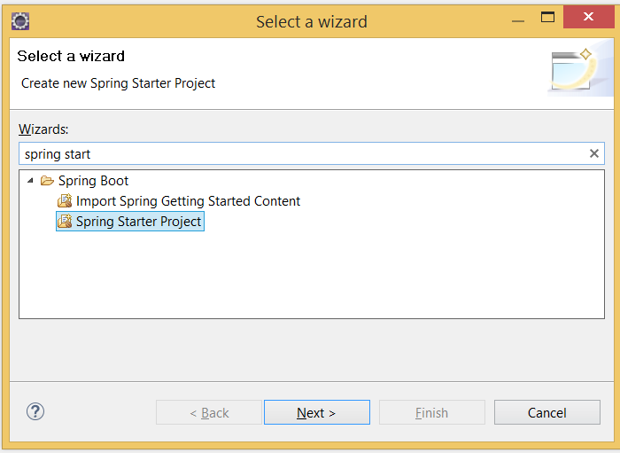
Please fill the following fields:
Name: firstSpringBootApp1
Group: springBootApp.examples
Artifact: firstSpringBootApp1
Package: springBootApp.examples.firstSpringBootApp1
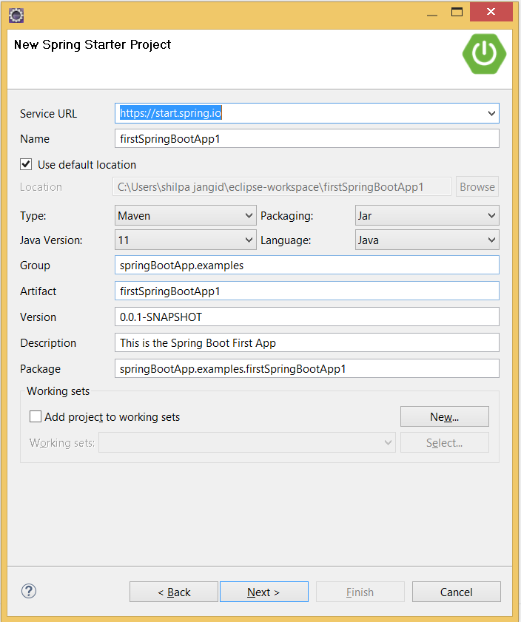
From the next window, type & select the dependencies if needed:
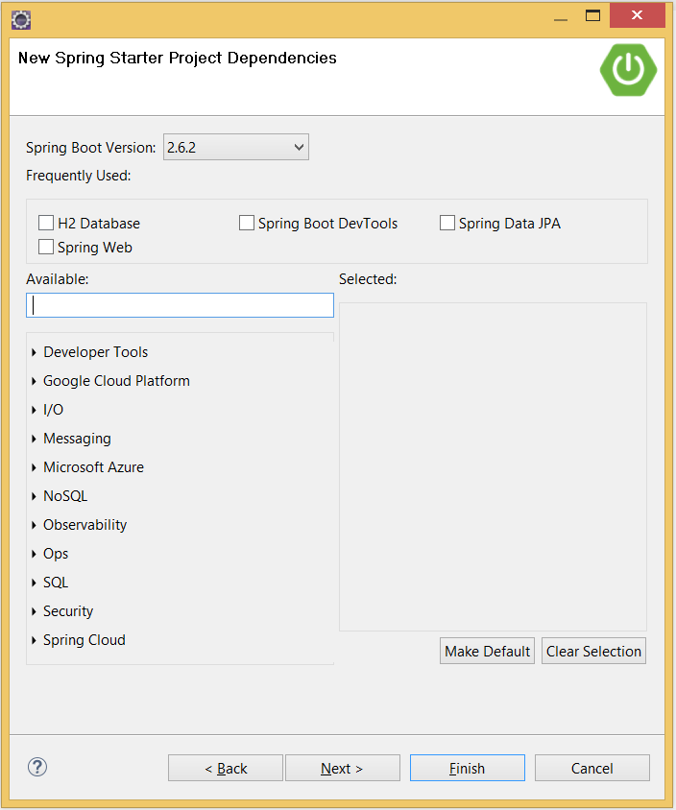
Click on next & Finish.
This is the first way to create a spring boot app. The second way to create Spring boot app is by the following link:
https://start.spring.io/
Set up the configuration and import in eclipse.
Project Structure:
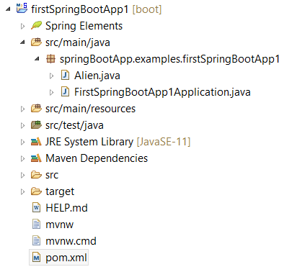
Alien.java class:
package springBootApp.examples.firstSpringBootApp1;

import org.springframework.stereotype.Component;

@Component
public class Alien {
private int alienId;
private String alienName;
private String alienTech;

public Alien() {
System.out.println("Alien Object Created");
}

public int getAlienId() {
return alienId;
}

public void setAlienId(int alienId) {
this.alienId = alienId;
}

public String getAlienName() {
return alienName;
}

public void setAlienName(String alienName) {
this.alienName = alienName;
}

public String getAlienTech() {
return alienTech;
}

public void setAlienTech(String alienTech) {
this.alienTech = alienTech;
}

@Override
public String toString() {
return "Alien [alienId=" + alienId + ", alienName=" + alienName + ", alienTech=" + alienTech + "]";
}
}
FirstSpringBootApp1Application
package springBootApp.examples.firstSpringBootApp1;
import org.springframework.boot.SpringApplication;
import org.springframework.boot.autoconfigure.SpringBootApplication;
import org.springframework.context.ConfigurableApplicationContext;
@SpringBootApplication
public class FirstSpringBootApp1Application {
public static void main(String[] args) {
ConfigurableApplicationContext context = SpringApplication.run(FirstSpringBootApp1Application.class, args);
Alien alien1 = context.getBean(Alien.class);
alien1.setAlienId(101);
alien1.setAlienName("Komal");
alien1.setAlienTech("I7 CPU Chip");
System.out.println(alien1.toString());
Alien alien2 = context.getBean(Alien.class);
alien2.setAlienId(101);
alien2.setAlienName("Komal");
alien2.setAlienTech("I7 CPU Chip");
System.out.println(alien2.toString());
}
}

